Actividad 1

setwd("C:/Users/Sena/Documents")
datos<-read.table("datos_est_analitica",sep=",", header = TRUE)
View(datos) library(fdth)
##
## Attaching package: 'fdth'
## The following objects are masked from 'package:stats': ##
## sd, var
#Variables Categóricas

summary(datos)

##  ## | X  Min. : |  | 1 | nombre  Length:17 |  |  | Min. | edad  :17.00 | estatura  Min. :1.550
## | 1st Qu.: |  | 5 | Class | :character |  | 1st Qu.:17.00 |  | 1st Qu.:1.630
## | Median : |  | 9 | Mode | :character |  | Median :18.00 |  | Median :1.680
## | Mean : |  | 9 |  |  |  | Mean :17.65 |  | Mean :1.689
##  ## ## | 3rd Qu.:13  Max. 17  Hobby |  |  | genero |  |  | 3rd Qu.:18.00 3rd Qu.:1.750  Max. :18.00 Max. :1.820  est_soc num_pers_vive
## | Length:17 |  |  | Length:17 |  |  | Min. :2.000 Min. :1.000
## | Class | :character |  |  | Class | :character |  | 1st Qu.:2.000 |  | 1st Qu.:2.000
##  ## ## | Mode | :character |  |  | Mode | :character |  | Median :3.000  Mean :2.765 3rd Qu.:3.000 |  | Median :3.000  Mean :2.941 3rd Qu.:3.000
## | Max. |  |  |  |  |  |  |  | :4.000 | Max. | :7.000
library(descr)
table1 <- freq(datos$genero, col=c("blue", "red"))

table2 <- table(datos$genero, datos$Hobby)
table2
##
##
videojuegos
cocinar comer deporte leer manejar maquillar pintar
##
0 ## 4
femenino
0
0
1
2
0
1
1
masculino
1
1
5
0
1
0
0
table3<-CrossTable(datos$Hobby, datos$genero, prop.chisq = F)#generar
tabla de contingencia
table3
## Cell Contents
## |
## |
|
N |
## ===========================================
##
## datos$Hobby ##
datos$genero
femenino
masculino
Total

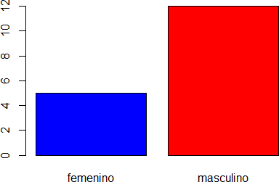

## | | |  | N / Row | Total | |
## | | |  | N / Col | Total | |
## | | |  | N / Table | Total | |
## | | |  |  |  | |
##

## cocinar 0 1 1
## 0.000 1.000 0.059
## 0.000 0.083
## 0.000 0.059 ##
## comer 0 1 1
## 0.000 1.000 0.059
## 0.000 0.083
## 0.000 0.059 ##
## deporte 1 5 6
## 0.167 0.833 0.353
## 0.200 0.417
## 0.059 0.294 ##
## leer 2 0 2
## 1.000 0.000 0.118
## 0.400 0.000
## 0.118 0.000 ##
## manejar 0 1 1
## 0.000 1.000 0.059
## 0.000 0.083
## 0.000 0.059 ##
## maquillar 1 0 1
## 1.000 0.000 0.059
## 0.200 0.000
## 0.059 0.000 ##
## pintar 1 0 1
## 1.000 0.000 0.059
## 0.200 0.000
## 0.059 0.000 ##
## videojuegos 0 4 4
## 0.000 1.000 0.235
## 0.000 0.333
## 0.000 0.235 ##
## Total 5 12 17
## 0.294 0.706
## ===========================================
barplot(prop.table(table(datos$genero,datos$Hobby)),col=c( "orange", "blue"), legend.text=c( "Femenino","Masculino"))#grafico de barras apiladas

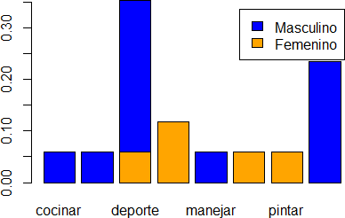

barplot(table2,main="Barras apiladas",xlab = "Hobby",ylab="frecuencia")#barras apiladas

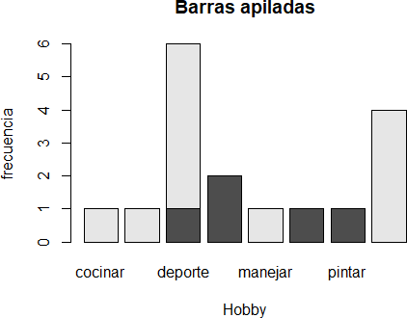

table4
## datos$num_pers_vive
##
## 1
Frequency Percent
2
11.765
table5<-table(datos$genero, datos$num_pers_vive)
barplot(table5,main="Barras")#barras apiladas
#variables cualitativas discretas

table4 <- freq(datos$num_pers_vive, col=c("blue", "red"))

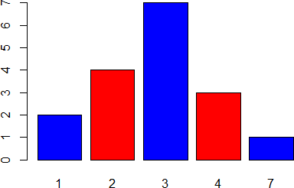

## | 2 | 4 | 23.529
## | 3 | 7 | 41.176
## | 4 | 3 | 17.647
## | 7 | 1 | 5.882
## | Total | 17 | 100.000

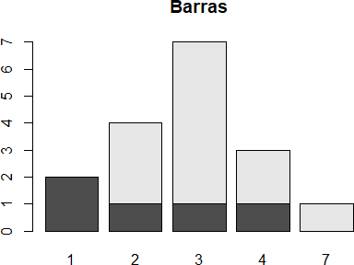

table5<-table(datos$genero, datos$est_soc)
barplot(table5,main="Barras")#barras apiladas

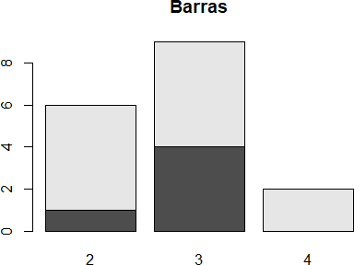

plot(table5, type="cfp")

#variables cuantitativas
dist<-fdt(datos$edad, breaks="Sturges"); dist
##
##
Class limits
[16.83,17.055)
f rf rf(%) cf
6 0.35 35.29
6
cf(%)
35.29
range(datos$edad)
## [1] 17 18
hist(datos$edad, breaks="Sturges", col="blue",main = "Histograma edad Est", xlab = "edad", ylab="Frecuencia")
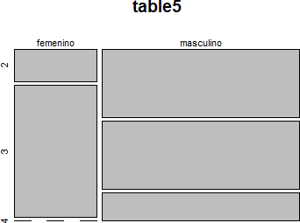

## | [17.055,17.28) | 0 | 0.00 | 0.00 | 6 | 35.29
## | [17.28,17.505) | 0 | 0.00 | 0.00 | 6 | 35.29
## | [17.505,17.73) | 0 | 0.00 | 0.00 | 6 | 35.29
## | [17.73,17.955) | 0 | 0.00 | 0.00 | 6 | 35.29
## | [17.955,18.18) | 11 | 0.65 | 64.71 | 17 | 100.00

nclass.Sturges(hist)
## [1] 1
dist2<-fdt(datos$estatura, breaks="Sturges"); dist
##
##
Class limits
[16.83,17.055)
f rf rf(%) cf
6 0.35 35.29
6
cf(%)
35.29
range(datos$estatura)
## [1] 1.55 1.82
hist(datos$estatura, breaks="Sturges", col="lightblue",main = "Histograma de estatura Estudiantes", xlab = "estatura", ylab="Frecuencia")
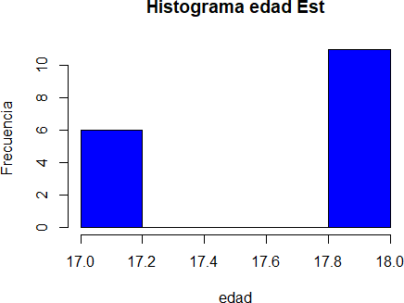

## | [17.055,17.28) | 0 | 0.00 | 0.00 | 6 | 35.29
## | [17.28,17.505) | 0 | 0.00 | 0.00 | 6 | 35.29
## | [17.505,17.73) | 0 | 0.00 | 0.00 | 6 | 35.29
## | [17.73,17.955) | 0 | 0.00 | 0.00 | 6 | 35.29
## | [17.955,18.18) | 11 | 0.65 | 64.71 | 17 | 100.00

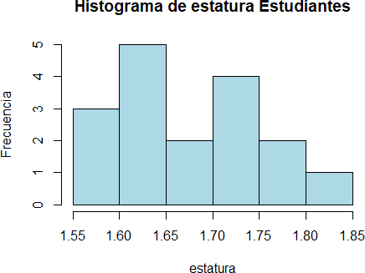

table1 <- table(datos$genero, datos$Hobby)
barplot(table1, col = c("blue","red"))

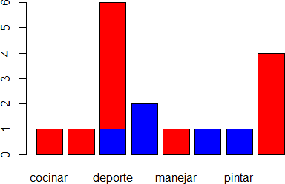

plot(dist, type="cfh", col="orange", main= "Grafica frecuencias acumuladas")#graficar frecuencia acumulada

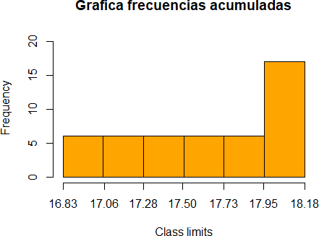

plot(dist2, type="fh", col="blue",main="Grafica frecuencias absolutas")#graficar frecuencia absoluta

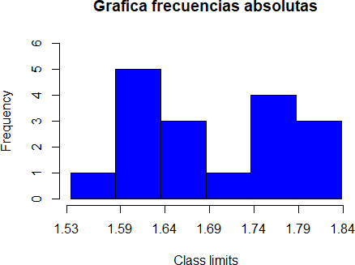

plot(dist, type="cfp")

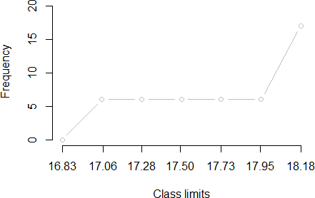

plot(dist2, type="cfp")

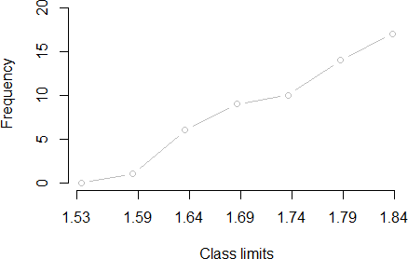

library(descr)
table1 <- freq(datos$genero, col=c("blue", "red"))

table3 <- table(datos$genero, datos$Hobby)
table3
##
##
videojuegos
cocinar comer deporte leer manejar maquillar pintar
##
0 ## 4
femenino
0
0
1 2
0
1
1
masculino
1
1
5 0
1
0
0
barplot(table3, col = c("blue","red"))

